**Bulk collect**

Bulk collect is about reducing context switching and improving the query performance.

Context switching

Whenever we write PL/SQL block and execute it. The PL/SQL runtime engine starts processing it line by line , this engine processes all the pl/sql statements by itself but it passes all the SQL statement to the SQL engine. Those SQL statements will then get processed separately by the SQL engine.

Once it is done processing then the SQL engine then return the result back to the PL/SQL engine.so that combined result can be produced latter.

This to and fro hopping of control is called context switching.

Bulk collect clause reduces multiple control hopping by collecting all the SQL statement calls from the PL/SQL program and sending them to SQL engine in just one go and vice verse.

**Definition**

Bulk collect clause reduces/compresses multiple switches into a single context switch and increases the efficiency and performance of a PL/SQL program.

The process of fetching batches of data from PL/SQL runtime engine to SQL runtime engine and vice versa is called bulk data processing.

Bulk collect clause can be used with

* SELECT – INTO
* FETCH – INTO
* RETURNING – INTO

Example of SELECT-INTO

set serveroutput on;

DECLARE

TYPE tab_name IS TABLE OF VARCHAR2(200);

rec_name tab_name;

BEGIN

SELECT first_name

INTO rec_name

FROM employees;

END;

In above example, incase employees table has 50 records then there will be 100 hopping between pl/sql and sql engine

1. From pl/sql engine to SQL engine
2. From SQL engine to pl/sql engine

And hence reducing the performance

It gives error as well

PLS-00642: local collection types not allowed in SQL statements

06550. 00000 - "line %s, column %s:\n%s"

*Cause: Usually a PL/SQL compilation error.

*Action:

Rewriting it

DECLARE

TYPE tab_name IS TABLE OF VARCHAR2(200);

rec_name tab_name;

BEGIN

SELECT first_name

BULK COLLECT INTO rec_name

FROM employees;

END;

Here instead of processing each row from plsql engine to sql engine , bulk collect with get all 50 records at a time and reduces the hopping to two.

DECLARE

TYPE tab_name IS TABLE OF VARCHAR2(200);

rec_name tab_name;

BEGIN

SELECT first_name

BULK COLLECT INTO rec_name

FROM employees;

FOR i in 1..rec_name.COUNT

LOOP

DBMS_OUTPUT.PUT_LINE('name is '||rec_name(i));

END LOOP;

END;

/

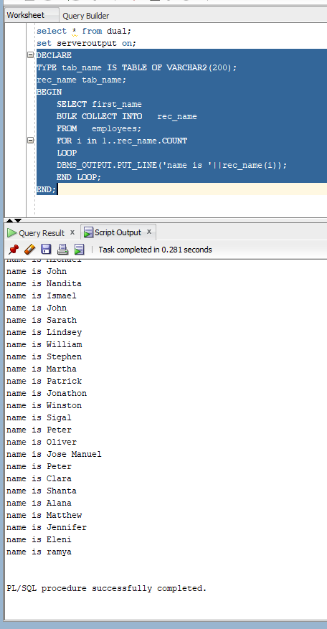

**FETCH INTO example**

SET sERVEROUTPUT ON;

DECLARE

CURSOR emp_cur IS

SELECT first_name

FROM employees;

TYPE my_name IS TABLE OF VARCHAR2(20);

rec_name my_name;

BEGIN

OPEN emp_cur;

LOOP

FETCH emp_cur BULK COLLECT INTO rec_name;

EXIT WHEN rec_name.count=0;

FOR i in 1..rec_name.count

LOOP

DBMS_OUTPUT.PUT_LINE('name is '||rec_name(i));

END LOOP;

END LOOP;

CLOSE emp_cur;

END;

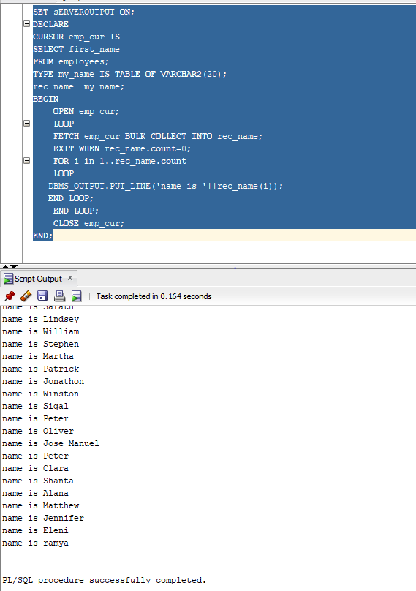

**LIMIT**

Bulk collect clause will cause memory overhead. Our programs start consuming a lot of memory in order to be fast and efficient .That degrades the performance of the database.

This means that our query must surely be performing well but at the same time our database may not.

SET sERVEROUTPUT ON;

DECLARE

CURSOR emp_cur IS

SELECT first_name

FROM employees;

TYPE my_name IS TABLE OF VARCHAR2(20);

rec_name my_name;

BEGIN

OPEN emp_cur;

FETCH emp_cur BULK COLLECT INTO rec_name **limit 10**;

FOR i in 1..rec_name.count

LOOP

DBMS_OUTPUT.PUT_LINE('name is '||rec_name(i));

END LOOP;

CLOSE emp_cur;

END;

**FORALL statement**

FORALL statement reduces context switches which occur during the execution of a DML statement in a loop.

FORALL is a bulk loop construct which executes one DML statement multiple times at once.

Syntax

FORALL index IN bound_clause

[SAVE EXECEPTION]

DML statement ;

Unlike FOR loop, with FORALL statement we can only use one DML at a time.

Bound clauses

The bound clause controls the value of index as well as decides the number of iteration of a FORALL statement.

There are three types

1. Lower and upper bound
2. Indices of
3. Values of

Example 1

create table tut_77(mul_9 number);

DECLARE

TYPE my_array IS TABLE of NUMBER INDEX BY PLS_INTEGER;

col_var my_Array;

tot_rec NUMBER;

BEGIN

FOR i in 1..10

LOOP

col_Var(i):=9*i;

END LOOP;

FORALL i in 1..10

insert into tut_77 values(col_Var(i));

select count(*)

into tot_rec

from tut_77;

DBMS_OUTPUT.PUT_LINE('Total records'||tot_rec);

END;

/

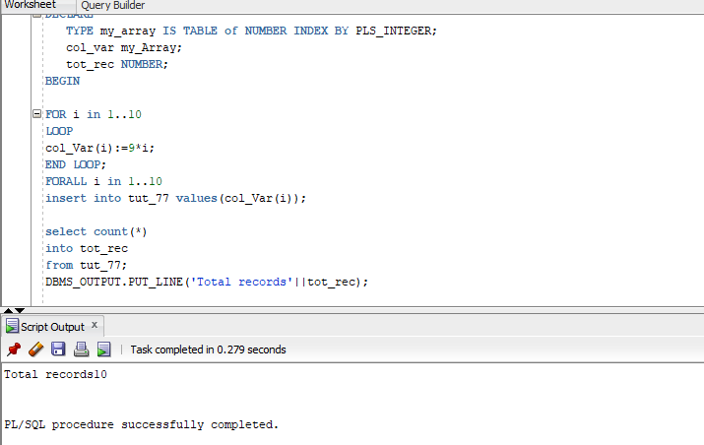

Example 2:

DECLARE

TYPE my_array IS TABLE of NUMBER ;

col_var my_Array:=my_Array(9,18,27,36,45,54,63,72,81,90);

tot_rec NUMBER;

BEGIN

col_Var.delete(3,6);

FORALL i in 1..10

insert into tut_77 values(col_Var(i));

rror report -

ORA-22160: element at index [3] does not exist

ORA-06512: at line 7

22160. 00000 - "element at index [%s] does not exist"

*Cause: Collection element at the given index does not exist.

*Action: Specify the index of an element which exists.

END;

/

Here because 4 elements are deleted from collection upper bound and lower bound throws error

It can solved by indices

DECLARE

TYPE my_array IS TABLE of NUMBER ;

col_var my_Array:=my_Array(9,18,27,36,45,54,63,72,81,90);

tot_rec NUMBER;

BEGIN

col_Var.delete(3,6);

FORALL i in **indices of col_var**

insert into tut_77 values(col_Var(i));

select count(*) into tot_rec from tut_77;

DBMS_OUTPUT.PUT_LINE('Total records inserted '||tot_rec);

END;

/

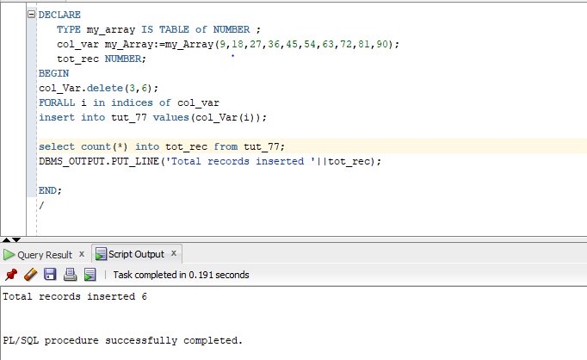

DECLARE

TYPE my_nested_Table IS TABLE of NUMBER ;

col_var my_nested_Table:=my_nested_Table(9,18,27,36,45,54,63,72,81,90);

TYPE my_Array is table of PLS_INTEGER index by PLS_INTEGER;

index_col my_Array;

BEGIN

index_col(1):=3;

index_col(5):=7;

index_col(12):=8;

index_col(28):=10;

FORALL i **in values of index_col**

insert into tut_77 values(col_Var(i));

END;

/

Disadvantages of BULK COLLECT

1. We cannot bulk collect into an associative array having a string type for the key.
2. Bulk collect can only be used at server side
3. Collections should be used as target variables listed in a bulk collect into clause
4. Composite targets (such as objects) cannot be used in the returning caluse
5. Multiple composite target cannot be used in the bulk collect when implicit datatypr conversion needed.